

|  |  |
| --- | --- |
| **name** | **ID** |
| Omar Abdulbaqi | 219110563 |
| Mohammed Alyami | 219110701 |

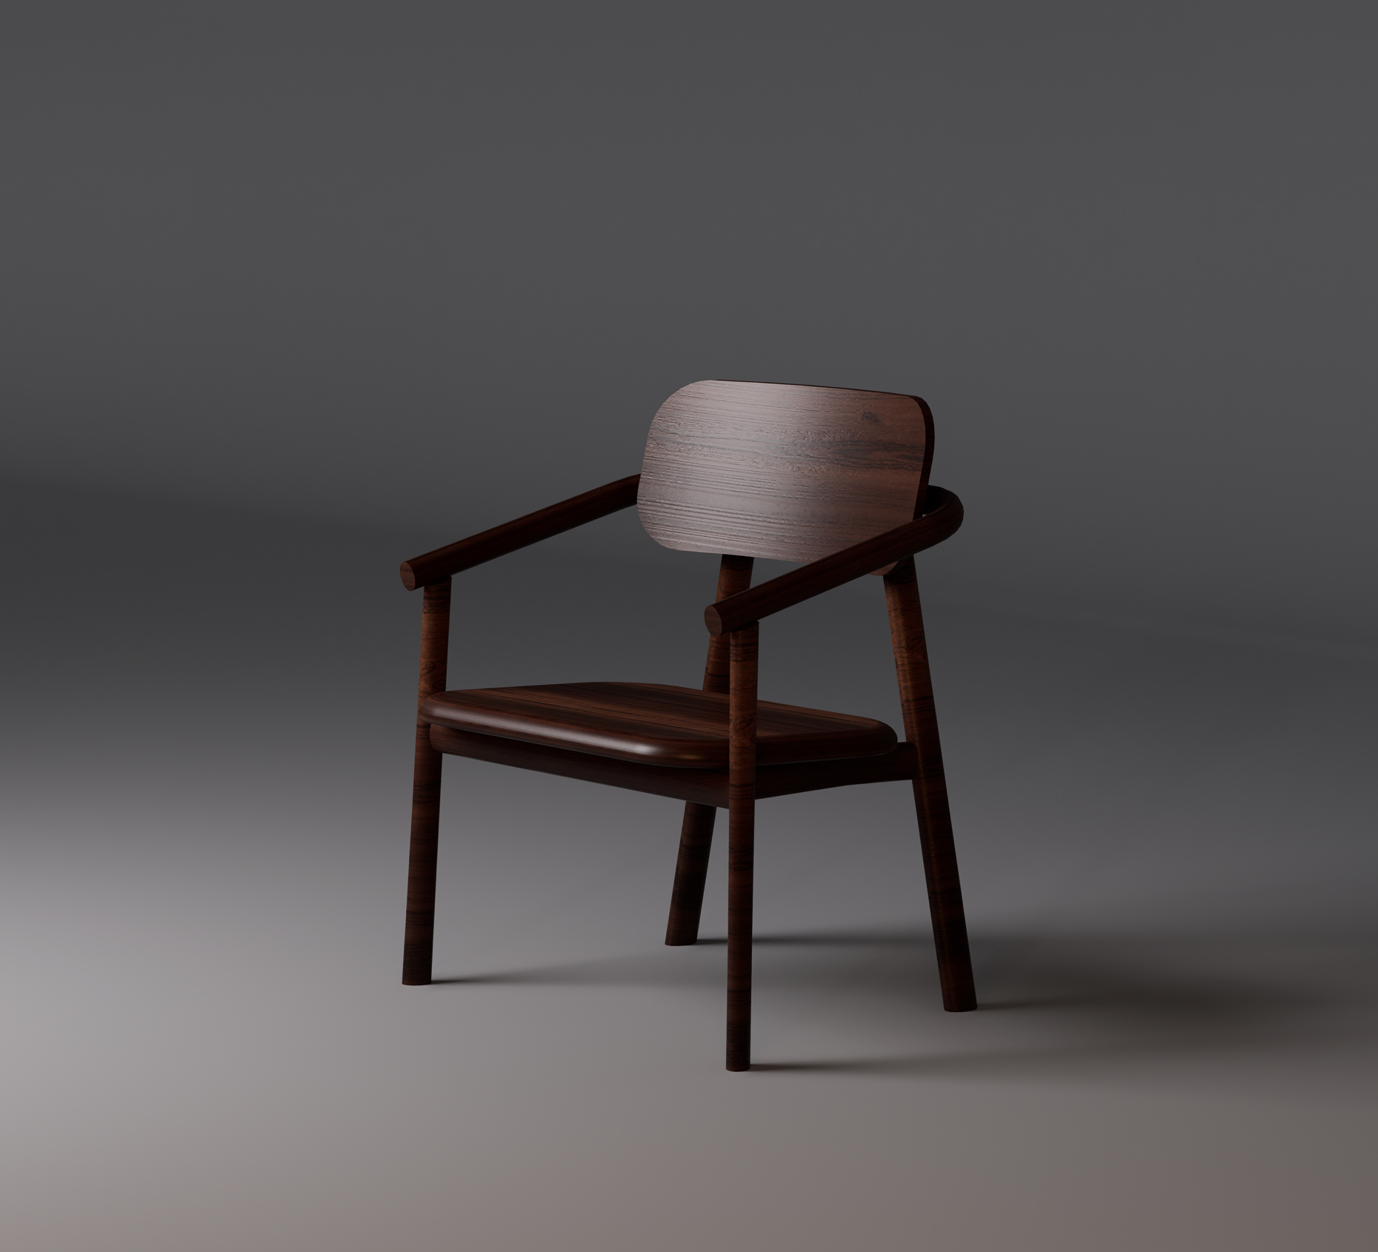

* Table of content:

-Introduction and demand expectation

-List of all cost and (D, I, F, V)

-CVP analysis including BE

-Job costing by using ABC

-Master Budget

-Pricing

* Introduction:

This report provides a comprehensive analysis of the production and financial planning for a furniture manufacturing project specializing in producing high-quality chairs. With an expected demand of 6,000 units per month, the business aims to achieve operational efficiency and maintain a competitive edge in the market by adopting advanced costing techniques and meticulous budget planning.

The report begins with a breakdown of costs, categorized into direct, indirect, fixed, and variable components. These include labor, raw materials, utilities, lease expenses, and setup costs. Using Activity-Based Costing (ABC), the cost of producing each chair was accurately calculated, allowing for a more precise allocation of overhead expenses. Further, a detailed master budget is presented, encompassing key elements such as the sales forecast, production plan, direct materials and labor budgets, overhead allocations, and the projected income statement. The findings demonstrate that the total cost per unit is $10.65, aligning with the company’s target pricing strategy of $40 per chair. This report highlights the financial viability of the project, supported by the ability to meet demand expectations while maintaining profitability. It serves as a roadmap for implementing efficient cost management and achieving the desired business outcomes.

* Product description

• Made entirely from durable, sustainable pine wood

• Natural wood finish showcasing the beauty of the grain

• Strong and sturdy design for long-term use

• Versatile style that complements various interior themes

* Demand expectation

**Chair Demand, Target, and Market Share**

The demand for high-quality, sustainable furniture, particularly wooden chairs, is growing as consumers seek durable, eco-friendly products. Our company targets a monthly production of 6,000 units (72,000 units annually), driven by strong interest in sustainable, well-crafted furniture for both residential and commercial spaces.

We aim to capture a significant share of the market for mid-range, high-quality wooden chairs, with a competitive price point of $40 per chair (below the market average of $45). Our target market includes:

Residential consumers seeking stylish, eco-conscious furniture.

Commercial spaces like restaurants, cafes, and offices.

Eco-conscious buyers who prioritize sustainability.

We plan to achieve a 5-10% market share in the growing segment of sustainable wooden furniture by focusing on product quality, sustainability, competitive pricing, and strong brand positioning. With an annual production capacity of 72,000 units, we aim to grow our market presence and build customer loyalty over time.

* List of all cost and (D, I, F, V)

|  |  |  |  |
| --- | --- | --- | --- |
| **Item** | **Cost** | **Fixed/ variable** | **Direct / indirect** |
| **Labor** | $75,600 | Fixed | Direct |
| **Insurance** | $2000 | Fixed | Direct |
| **Raw material** | $576,000 | variable | Direct |
| **Utilities** | $11,000 | variable | indirect |
| **Depreciation** | $3,000 | Fixed | indirect |
| **Supply** | $1,000 | variable | indirect |
| **Holding cost** | $72,000 | Fixed | indirect |
| **Setup** | $10,800 | variable | Direct |
| **Indirect material** | $3,000 | variable | indirect |
| **Lease** | $20,000 | Fixed | indirect |

* Materials cost
* Pine wood: Each pine wood sheet produces two chairs, with a cost of $16 per sheet, resulting in a wood cost of **$8 per chair.**
* Glue: 1L of glue is $10 and each chair needs 30ml: 0.03L*72,000 = 2160L* 10 = $21,600 / 72,000 = $0.3
* Screws: each chair needs 16 screw * 72,000 = 1,152000 screw and each screw cost is **$0.01875 * 16 = $0.3**
* Paint: each chair consumes 250 ml and each L of paint cost $12.64 / 4chairs = $3.16 per chair

|  |  |  |  |
| --- | --- | --- | --- |
| **Material** | **Usage (per chair)** | **Unit cost ($)** | **Cost per chair ($)** |
| **Pine wood** | ½ sheet | 16 per sheet | 8 |
| **Glue** | 30 ml | 10 per liter | 0.3 |
| **Screw** | 16 screws | 0.01875 per screw | 0.3 |
| **Paint** | 250 ml | 12.64 per liter | 3.16 |

* Chair production process

|  |  |  |  |
| --- | --- | --- | --- |
| **Process** | **Number of Labors** | **Time (minutes)** | **Description** |
| **Cutting** | 1 | 15 | Raw pine wood is cut into pieces to form the chair's frame and components. |
| **Grinding** | 1 | 10 | The wood pieces are sanded down to smooth surfaces, preparing them for assembly and painting. |
| **Painting** | 1 | 20 | The wood pieces are sanded down to smooth surfaces, preparing them for assembly and painting. |
| **Assembly** | 3 | 10 | Workers attach all components using screws and glue, completing the construction of the chair. |

* CVP analysis including BE
* Selling price per chair is $**40**
* Variable cost per chair is **$8.34**
* Fixed cost is **$169,600**
* Contribution margin per chair = selling price – variable cost

$40 - $8.34 = **$31.66**

* Break-even point = fixed cost / contribution margin

$169,600 / $31.66 = **5357** chair

* Activity-based costing

|  |  |  |  |  |  |
| --- | --- | --- | --- | --- | --- |
| **Activity** | **Total O.H($)** | **Cost driver** | **Driver units** | **Activity rate** | **Cost per chair** |
| **Facility lease** | 20,000 | # of units | 72,000 | 0.28 | $0.28 |
| **Holding cost** | 72,000 | # of units | 72,000 | 1 | $1 |
| **Security** | 10,200 | Labor hour | 72,000 | 0.14 | $0.14 |
| **Setup cost** | 10,800 | # of setups | 12 | 900 per setup | $0.15 |

Using activity-based costing (ABC) we figured out that the rates per chair is equal to:

* Facility lease = $0.28
* Holding inventory = $1
* Security and depreciation = $0.142
* Setup = $0.15
* Overhead per chair = $1.572

-Summary of job costing

|  |  |
| --- | --- |
| **Cost component** | **Cost per chair ($)** |
| **Direct materials** | 8.03 |
| **Direct labor** | 1.05 |
| **Overhead (ABC)** | 1.572 |
| **Total job cost** | 10.652 |

At **$10.652 per chair**, the production process balances material quality and labor efficiency while maintaining reasonable overhead expenses.

* Master budget

A master budget is a comprehensive financial planning document that includes operating and financial budgets for the business. Based on the above information, the master budget for the year, will include:

1. Sales Budget  
2. Production Budget  
3. Direct Materials Budget  
4. Direct Labor Budget  
5. Overhead Budget  
6. Cost of Goods Manufactured (COGM) Budget  
7. Income Statement Budget

1. Sales Budget  
Annual Total: 72,000unit * $40 = $2,880,000

2. Production Budget  
Annual Total 72,000 unit

3. Direct Materials Budget  
Total $577,440

4. Direct Labor Budget  
Total $75,600

5. Overhead Budget  
Overhead Item Annual Cost ($)  
Facility Lease 20,000  
Holding Costs 72,000  
Utilities (Electricity) 10,000  
Utilities (Water) 1,000  
Depreciation 3,000  
Supplies 1,000  
Total Overhead 107,000

6. Cost of Goods Manufactured (COGM) Budget  
Cost Component Annual Cost ($)  
Direct Materials $577,440  
Direct Labor $75,600  
Overhead $107,000  
Total COGM $760,040  
  
  
7. Budgeted Income Statement  
Item Annual Amount ($)  
Sales Revenue 2,880,000  
Cost of Goods Sold (COGS) $760,040  
Gross Profit $2,119,960

Operating Expenses $2,078,760

Net Operating Income $41,200

* Pricing

We used target pricing to calculate the price of the chair, we compared it to the market. The average price is $45, and we want to earn $29.3 per markup, so the price of the chair will be $10.652 + $29.3 = $40

total cost = $766,944

cost per chair = $10.652